


Experiment No.: 6

Title

Vacuum Cleaner Problem using Python

Aim

To implement the Vacuum Cleaner Problem using Python.

Apparatus / Software Required

Computer or Laptop

Python 3.x

IDLE / VS Code / PyCharm (Any Python IDE)

Windows Operating System

Procedure

Open the Python IDE.

Create a new Python file.

Write the Python program for the Vacuum Cleaner Problem.

Save the file with the .py extension.

Run the program.

Initialize the rooms with clean or dirty status.

The vacuum cleaner checks each room and cleans it if necessary.

Display the final status of all rooms.

Verify the output.

Close the program.

Program
rooms = {'A':'Dirty','B':'Dirty'}

location = 'A'

while True:

if rooms[location] == 'Dirty':

print("Cleaning", location)

rooms[location] = 'Clean'

if location == 'A':

location = 'B'

else:

break

print(rooms)

Sample Output

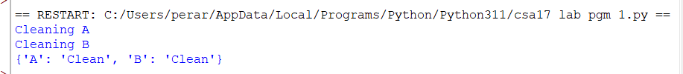

Result

Thus, the Python program to implement the Vacuum Cleaner Problem was executed successfully, and all dirty rooms were cleaned.

